Joel Edwards
Course: Java Programming 1
Homework 2
April 7, 2011

A.1) "new" is a reserved word.

A.2) This is a problem if "y" has not yet been declared.

A.3) No output as the only statement which would generate output is commented out.

A.4) The results are the same.
char c = 'A' - assigns a character constant to 'c'
char c = 65 - casts the integer value 65 to a character before storing to 'c'.

A.5)
r3d3 - Valid
_12345 - Valid
California - Valid
U.S.A - Invalid because the . is a separator
$value - Valid
Private - Valid
2number - Invalid because identifiers cannot begin with a digit
X(3) - Invalid because parenthesis are disallowed within identifier names

A.6)
37 % 5 % 3 = 2
37 % (5 % 3) = 1

A.7)
m = 42
n = 41

A.8)
m = 6
n = 1

A.9)
a. float f = 345.6; - it won't compile due to a difference in precision between the variable and the literal
b. int a = 35; - No issue

A.10) This will not compile correctly because because there is no guarantee that the variable 'n' has been initialized.

A.11)
a. zero (0)
b. one (1)

A.12)
a = 44 - The value is truncated to the least significant byte

A.13)
0
throws ArrayIndexOutOfBoundsException

A.14)
int i = 1;
while (i <= m) {
System.out.println(i);
i++;
}

A.15)
a.
g = 25
c = 6
b.
g = 0
c = 5

A.16)
a. x = 15
b. x = 35
c. x = 35

A.17) half = 0

A.18)
int totalSeconds = 370;
int minutes = totalSeconds / 60; // whole minutes
int seconds = totalSeconds % 60; // remaining seconds

A.19) a = 10

B.1)

Source:

Compare_abc.java:
import java.util.ArrayList;
import java.util.Comparator;
import java.util.Iterator;
import java.util.TreeSet;

class Compare_abc
{
private static final int ARG_COUNT = 3;

public static void main(String args[]) {
if (args.length != ARG_COUNT) {
System.out.println("Compare_abc: " +ARG_COUNT+ " arguments required");
System.exit(1);
}

TreeSet<ArrayList<Object>> tree = new TreeSet<ArrayList<Object>>(new Comparator<ArrayList<Object>>()
{
public int compare(ArrayList<Object> a, ArrayList<Object> b) {
Integer a_val = (Integer)a.get(1);
Integer b_val = (Integer)b.get(1);
if (a_val > b_val) {
return 1;
} else if (a_val < b_val) {
return -1;
} else {
String a_name = (String)a.get(0);
String b_name = (String)b.get(0);
return a_name.compareTo(b_name);
}
}
});

try {
for (int i = 0; i < args.length; i++) {
ArrayList<Object> p = new ArrayList<Object>();
p.add((char)((65 | 32) + i) + "");
p.add(Integer.parseInt(args[i]));
tree.add(p);
}
} catch (NumberFormatException e) {
System.out.println("Compare_abc: all " +ARG_COUNT+ " arguments must be integers");
System.exit(1);
}

Iterator iter = tree.iterator();

ArrayList<Object> last = (ArrayList<Object>)(iter.next());
String name = (String)last.get(0);
System.out.print(name);
while (iter.hasNext()) {
String separator = "<";
ArrayList<Object> item = (ArrayList<Object>)(iter.next());
Integer val = (Integer)item.get(1);
Integer last_val = (Integer)last.get(1);
if (val == last_val) {
separator = "=";
}
name = (String)item.get(0);
System.out.print(" " +separator+ " " +name);
last = item;
}
System.out.println("");
}
}

Output:
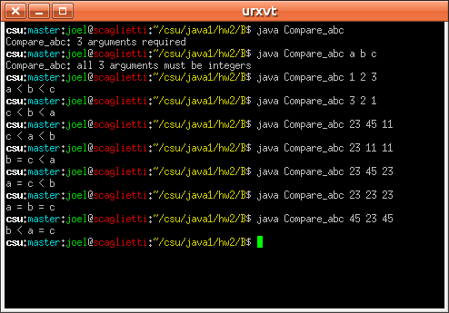

B.2)

Source:

Digits.java:
class Digits
{
public static void main(String args[]) {
if (args.length != 1) {
usage();
}

int digit = 0;
try {
digit = Integer.parseInt(args[0]);
} catch (NumberFormatException e) {
usage();
}

if ((digit < 0) || (digit > 9)) {
usage();
}

String text = "";

switch (digit) {
case 0: text = "zero"; break;
case 1: text = "one"; break;
case 2: text = "two"; break;
case 3: text = "three"; break;
case 4: text = "four"; break;
case 5: text = "five"; break;
case 6: text = "six"; break;
case 7: text = "seven"; break;
case 8: text = "eight"; break;
case 9: text = "nine"; break;
//default: text = "uknown"; break;
}

System.out.println(text);
}

private static void usage() {
System.out.println("usage: Digits <digit>");
System.out.println(" digit must be an integer digit between 0 and 9");
System.exit(1);
}
}
Output:
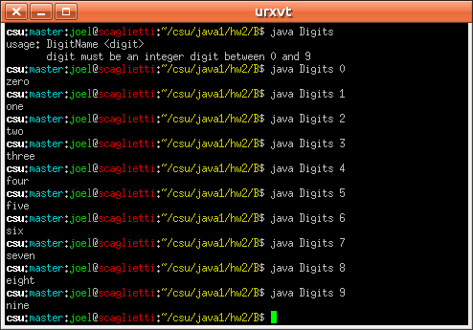

B.3)

Source:

Graph.java:
class Graph
{
public static void main(String args[]) {
for (String arg: args) {
try {
Integer.parseInt(arg);
} catch (NumberFormatException e) {
usage();
}
}

for (String arg: args) {
StringBuilder builder = new StringBuilder();
int length = Integer.parseInt(arg);
for (int i=0; i<length; i++) {
builder.append('*');
}
System.out.println(builder.toString());
}
}

private static void usage() {
System.out.println("usage: DigitName [val1 [val2 ...]]");
System.out.println(" val1, val2, etc. must be integers");
System.exit(1);
}
}

Output:
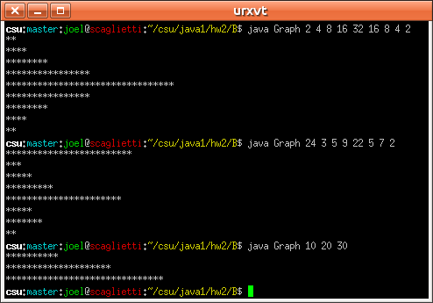

B.4)

Source:

BubbleSort.java:
class BubbleSort
{
public static void main(String args[]) {
double[] values = new double[args.length];

for (int i = 0; i < args.length; i++) {
try {
values[i] = Double.parseDouble(args[i]);
} catch (NumberFormatException e) {
usage();
}
}

sort(values);

for (double value: values) {
System.out.print(value+ " ");
}
System.out.println("");
}

private static void sort(double[] values) {
boolean swap_occurred = true;
int count = values.length;
double temp = 0;
while (swap_occurred) {
swap_occurred = false;
for (int i = 0; i < (count - 1); i++) {
if (values[i] > values[i+1]) {
temp = values[i];
values[i] = values[i+1];
values[i+1] = temp;
swap_occurred = true;
}
}
count--;
}
}

private static void usage() {
System.out.println("usage: DigitName [val1 [val2 ...]]");
System.out.println(" val1, val2, etc. must be integers");
System.exit(1);
}
}

Output:
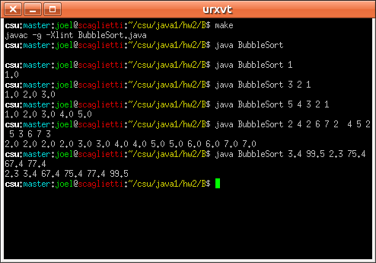

B.5)

Source:

MagicSquares.java:
class MagicSquares
{
public static void main(String args[]) {
if (args.length != 1) {
usage();
}

int n = 0;
try {
n = Integer.parseInt(args[0]);
} catch (NumberFormatException e) {
usage();
}

if ((n % 2) != 1) {
usage();
}

int[][] result = solve(n);

display(result, n);
}

public static void display(int[][] square, int n) {
int cmax;
int max = cmax = n * n;
int width = 1;
while (cmax >= 10) {
width++;
cmax /= 10;
}

for (int y = 0; y < n; y++) {
for (int x = 0; x < n; x++) {
System.out.print(String.format(String.format(" %%%dd", width), square[x][y]));
}
System.out.println("");
}
}

public static int[][] solve(int n) {
int max = n * n;
int[][] square = new int[n][n];
int x = n / 2;
int y = 0;

for (int k = 1; k <= max; k++) {
if (square[x][y] != 0) {
if (y == (n - 2)) {
y = 0;
} else if (y == (n - 1)) {
y = 1;
} else {
y += 2;
}
if (x == (n - 1)) {
x = 0;
} else {
x++;
}
}
square[x][y] = k;
if (x == 0) {
x = n - 1;
} else {
x--;
}
if (y == 0) {
y = n - 1;
} else {
y--;
}
}

return square;
}

private static void usage() {
System.out.println("usage: MagicSquares <size>");
System.out.println(" size - must be an odd integer");
System.exit(1);
}
}

Output:
